**STUDENT PROJECCT REPORT**

1. **Problem Statement:**

**Design a program of performing basic operations on the**

**results of the students for a school using java 8.**

1. **FEATURES:**

* **Java 8**
* **Collection**
* **I/O Programming**

1. **Abstract:**

**It is an application developed in java which is used to store all information for school records. The objective of this system is to test and performs java 8 features and get more familiar with java.**

**Some java 8 features:**

* **forEach() method in Iterable interface.**
* **default and static methods in Interfaces.**
* **Functional Interfaces and Lambda Expressions.**
* **ava Stream API for Bulk Data Operations on Collections.**

**4. Solution:**

**4.1 Create modules:**

* **Student**
* **Functions**
* **StudentHandlingException**
* **Validation**
* **Tester**

**4.2 Create members and methods as per requirement**

* **totalMarks()**
* **pertCalculate()**
* **parseDate()**

**4.3 Test your modules**

* **Main()**

**5.Diagrams**

**Fig 5.1 Flow chart**

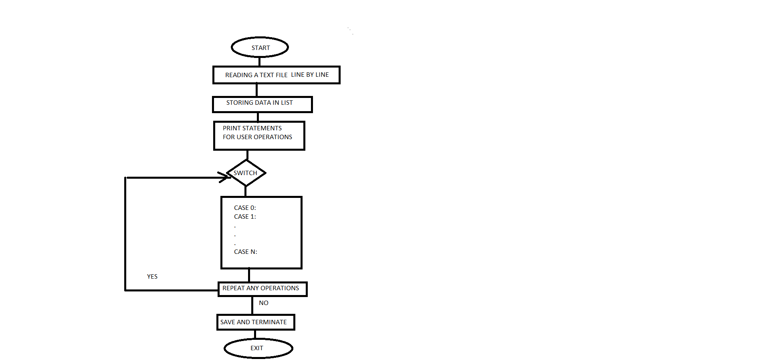

Fig 5.2 Class Diagram

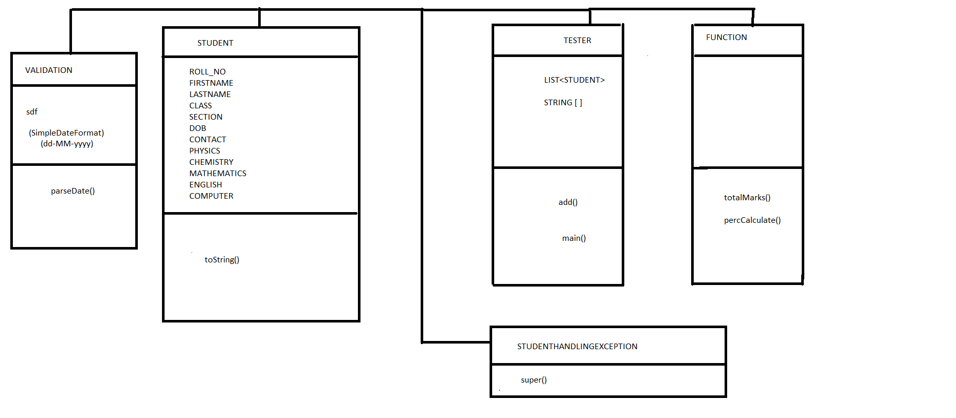

References:

<https://docs.oracle.com/javase/8/docs/api/>

<https://www.javatpoint.com/collections-in-java>

<https://www.geeksforgeeks.org/collections-in-java-2/>